**17 April 2012**  
**Summary:**  
-Converted CT 1-4, EST 1-4 gonadal RNA tissue to cDNA.  
-Ran qPCR on gonadal tissues  
  
Procedure:  
-For cDNA conversion lab protocol was followed  
  
SPEC OF GONADAL TISSUE

|  |  |
| --- | --- |
| SAMPLE | ng/ul |
| CT1 | 55.61 |
| 2 | 74.9 |
| 3 | 74.5 |
| 4 | 85.9 |
| EST 1 | 153.97 |
| 2 | 85.6 |
| 3 | 86.0 |
| 4 | 146.1 |

|  |  |  |
| --- | --- | --- |
| Sample | RNA USED (ul) | H2O USED (ul) |
| CT1 | 17.75 | 0 |
| CT2 | 13.18 | 4.57 |
| CT3 | 13.25 | 4.5 |
| CT4 | 11.49 | 6.26 |
| EST1 | 6.41 | 11.34 |
| EST2 | 11.53 | 6.22 |
| EST3 | 11.47 | 6.28 |
| EST4 | 6.76 | 10.99 |

-For qPCR procedure was done to lab protocol  
-Gonadal tissue with 2 primers, vitellogenin and estrogen receptor, same as 05 April 2012  
-Master mix same as 21 March 2012  
  
Amplification Curve  
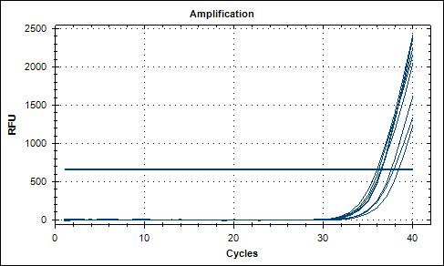  
  
Melting Peak  
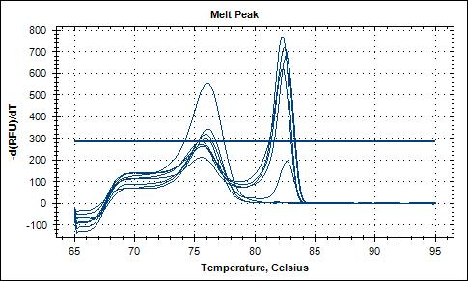  
  
Melting Curve  
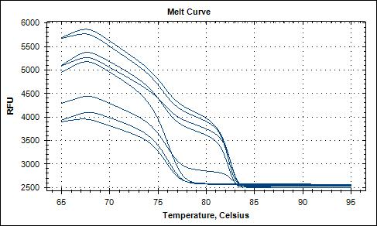  
  
Well Placement  
-Column 1: Vitellogenin primers  
-Column 2: Positive controls and No templates  
-Column 3: ER2 Primers

|  |  |  |  |
| --- | --- | --- | --- |
| Well | 1 | 2 | 3 |
| A | CT1 | Vg Pos. Con. | CT1 |
| B | CT2 | Vg No Temp. | CT2 |
| C | CT3 | Vg No Temp. | CT3 |
| D | CT4 | Blank | CT4 |
| E | EST1 | Blank | EST1 |
| F | EST2 | ER2 Pos. Con. | EST2 |
| G | EST3 | ER2 No Temp. | EST3 |
| H | EST4 | ER2 No Temp. | EST4 |

**05 April 2012**  
**Summary:**  
-Running qPCR for gill tissues using both Vg and ER2 primers.  
-Vg samples used 2ul of templates versus only 1 ul of template in ER2 samples  
  
**Procedure:**  
-Master mix same as on 21 March 2012, only difference is Vg samples 2ul of template were used.  
  
Well Placement:

|  |  |  |  |
| --- | --- | --- | --- |
| Well | 3 (All Vg Primers) | 4 | 5 (All ER2 Primers) |
| 1 | CT1 | Vg Positive Control | CT1 |
| 2 | CT2 | Vg - No template | CT2 |
| 3 | CT3 | Vg - No template | CT3 |
| 4 | CT4 |  | CT4 |
| 5 | EST1 |  | EST1 |
| 6 | EST2 | ER2 Positive Control | EST2 |
| 7 | EST3 | ER2 - No template | EST3 |
| 8 | EST4 | ER2 - No template | EST4 |

Amplification Curve  
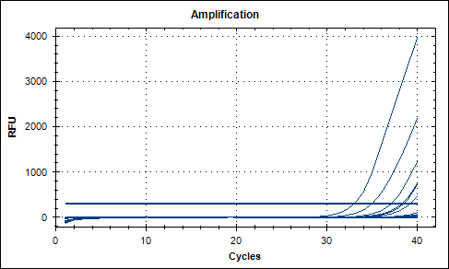  
  
Melting Peaks  
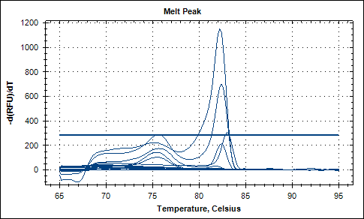  
  
**Next Step:**  
-Run Gonadal Tissue

**21 March 2012**  
**Summary:**  
-Running elongation factor with gill tissues x8 and positive control  
  
**Procedure:**  
-qPCR was done to lab protocol  
  
Master mix - Total reaction 20 ul  
So fast 10ul each x12 = 120ul  
forward .5ul x12 = 6ul  
Reverse .5ul x12 = 6 ul  
H2O 8ul x12 = 96ul  
  
Well Placement - All Gill Tissue  
-Each (CT1, CT2) indicates the gill tissue from one oyster, CT = Control, EST = exposed

|  |  |  |
| --- | --- | --- |
| Well | 1 | 2 |
| 1 | CT1 | POSITIVE CONTROL |
| 2 | CT2 | NO TEMPLATE |
| 3 | CT3 | NO TEMPLATE |
| 4 | CT4 |  |
| 5 | EST 1 |  |
| 6 | EST 2 |  |
| 7 | EST 3 |  |
| 8 | EST 4 |  |

Amplification Graph  
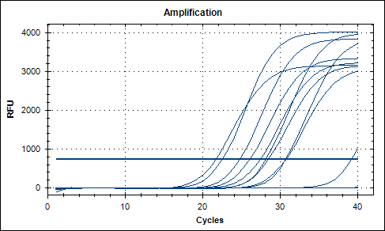  
  
Melting Graph  
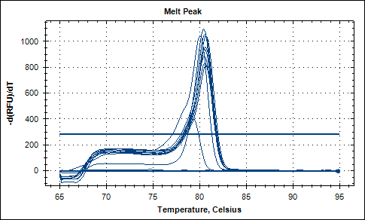  
  
  
**Next Step:**  
-Run ER qPCR

**13 March 2012**  
**Summary:**  
-Ran qPCR for Gill tissues with vitellogenin primer 1346/1345 (SRID)  
-Total 11 samples, 8 gill tissue, 1 Vg control and x2 no templates  
  
**Procedure:**  
-Procedure was done to lab protocol.  
-For clarification (CT1) is the name assignment to oyster control number 1, for each oyster like CT1 I took x4 tissue samples, this qPCR only is testing GILL tissue from the x8 oysters in my experiment. CT refers to controls and EST refers to estrogen treated.  
  
Amplification Graph  
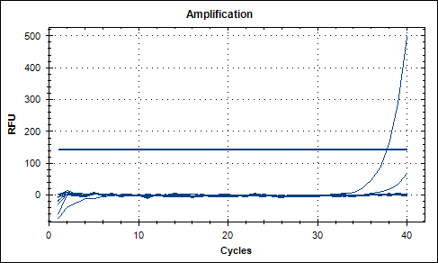  
Fig 1: The 1st line is amplification of the vitellogenin primer positive control.  
  
Melting Curve  
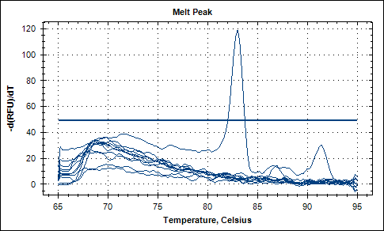  
  
Table: Well Placement, Gill tissue

|  |  |  |
| --- | --- | --- |
| Well | 6 | 7 |
| 1 | CT1 | VG POS. CONTROL |
| 2 | CT2 | NO TEMPLATE |
| 3 | CT3 | NO TEMPLATE |
| 4 | CT4 |  |
| 5 | EST1 |  |
| 6 | EST2 |  |
| 7 | EST3 |  |
| 8 | EST4 |  |

**Next Step:**  
-Run elongation factor to test validity of cDNA with gill tissues

**12 March 2012**  
**Summary:**  
-Ran qPCR with GIll tissue cDNA  
-total of 14 samples, 8 gill tissue, 1 vitellogenin control, 1 estrogen control, x2 no templates for each set of primers  
-qPCR for vitellogenin showed no amplification, either tissues or control.  
-qPCR for estrogen receptor gene showed good positive result.  
  
**Procedure:**  
-qPCR procedure was done to lab protocol  
Table: well placement

|  |  |  |
| --- | --- | --- |
| Well | 1 | 2 |
| 1 | CT1 | Vg Control |
| 2 | CT2 | NO TEMP. |
| 3 | CT3 | NO TEMP. |
| 4 | CT4 |  |
| 5 | EST1 |  |
| 6 | EST2 | ER CONTROL |
| 7 | EST3 | NO TEMP. |
| 8 | EST4 | NO TEMP. |

AMPLIFICATION RESULTS:  
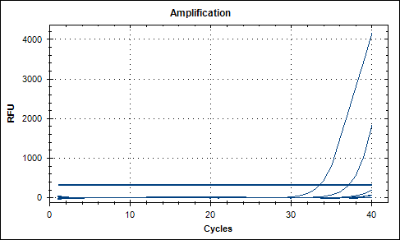  
Fig 1: The 1st peak is amplification of the ER primers and the second is contamination from the first ER no template.  
  
Melting Curve:  
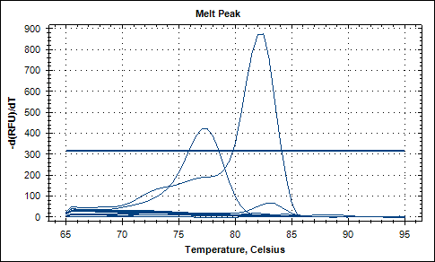  
Fig 2: The first peak (to 420) is contamination of the 1st no template control, The second peak is the positive control  
for the estrogen receptor primers in combination with pooled cDNA.  
  
**Next Step:**  
-Rerun vitellogenin primer with gill tissue  
-Next run tissues with ER primer

**07 March 2012**  
**Summary:**  
-Only running one set of tissues, GILL for all 8 oysters sampled.  
-Converted DNAsed RNA to cDNA for Gill tissues samples.  
  
**Procedure:**  
-Procedure was done to protocol.  
  
-Spec of Gill samples and conversion to 1ug used in cDNA

|  |  |  |  |  |  |
| --- | --- | --- | --- | --- | --- |
| Gill Tissue | ng/ul | 260/280 | 260/230 | RNA used (ul) | H2O used (ul) |
| CT1 | 621.59 | 1.99 | 1.58 | 1.61 | 16.14 |
| CT2 | 73.50 | 2.01 | 1.20 | 13.61 | 4.14 |
| CT3 | 71.03 | 1.99 | 1.39 | 14.08 | 3.67 |
| CT4 | 100.2 | 2.01 | 1.24 | 9.98 | 7.77 |
| EST1 | 100.6 | 2.01 | 1.46 | 9.94 | 7.80 |
| EST2 | 78.5 | 1.95 | 1.06 | 12.74 | 5.01 |
| EST3 | 81.2 | 2.00 | 1.32 | 12.31 | 5.44 |
| EST4 | 68.5 | 1.96 | 0.88 | 14.59 | 3.15 |

**Next Step:**  
-Run qPCR on cDNA samples for GIll tissue

**06 March 2012**  
**Summary:**  
-Ran DNAse procedure for samples CT2-4 and EST 2-4  
  
**Procedure:**  
-Procedure was done to commerical protocol from Roberts lab, I used the rigourous treatment due to the large amount of RNA in each sample.  
-Each .5ml tube contains 5ug of RNA per 50ul of solution.

|  |  |  |
| --- | --- | --- |
| Sample | RNA ul | DEPC H2O ul |
| CT2 GILL | 3.93 | 46.07 |
| MANTLE | 6.71 | 43.29 |
| MUSCLE | 7.59 | 42.41 |
| GONAD | 4.13 | 45.87 |
| CT3 GILL | 8.07 | 41.93 |
| MANTLE | 14.63 | 35.37 |
| MUSCLE | 44.74 | 5.26 |
| GONAD | 14.83 | 35.17 |
| CT4 GILL | 11.07 | 38.93 |
| MANTLE | 8.53 | 41.47 |
| MUSCLE | 32.06 | 17.94 |
| GONAD | 10.92 | 39.08 |
| EST2 GILL | 8.65 | 41.35 |
| MANTLE | 8.54 | 41.46 |
| MUSCLE | 26.89 | 23.11 |
| GONAD | 3.87 | 46.12 |
| EST3 GILL | 4.54 | 45.46 |
| MANTLE | 8.39 | 41.61 |
| MUSCLE | 9.01 | 41.00 |
| GONAD | 5.83 | 44.17 |
| EST4 GILL | 6.97 | 43.03 |
| MANTLE | 19.47 | 30.52 |
| MUSCLE | 7.32 | 42.68 |
| GONAD | 8.81 | 41.19 |

**Next Step:**  
-Spec samples that I will convert to cDNA and run qPCR  
-Run qPCR

**05 March 2012**  
**Summary:**  
-RNA qPCR analysis for 8 samples as listed on 01 March 2012.  
  
RNA Amplification Graph - All samples showed negative for genomic material except the positive control (exponential curve) and CT1 Muscle (only slight product at the 38th cycle.  
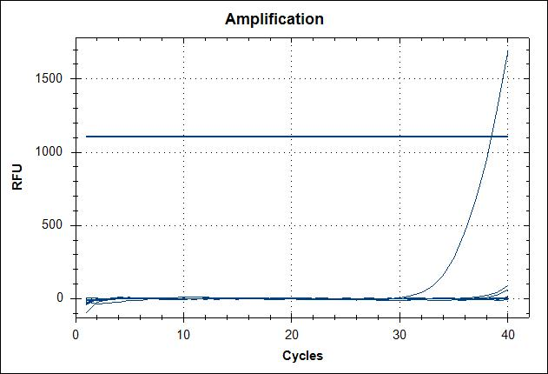  
  
RNA Melting Curve - Positive control peak shows up well on melting point graph and CT1 Muscle "hump" can be seen between 82 and 85C. The product was amplified so late in the cycles (38) that it shouldn't be of concern.  
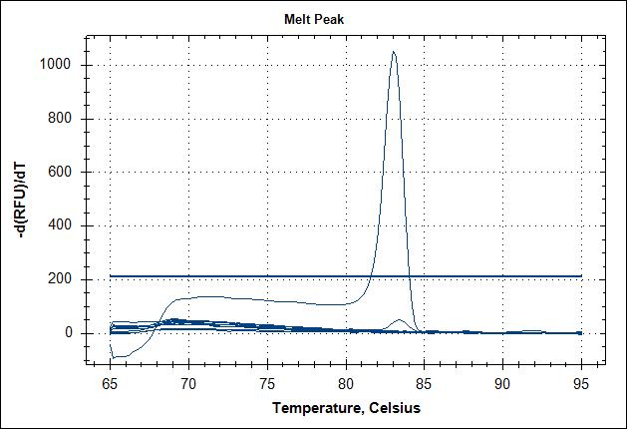  
  
**Next Step:**  
-Treat last 24 samples with DNAse and prepare to run the on Wednesday 07 March 2012 through qPCR.  
-By 09 March 2012, like to convert all RNA to cDNA and run qPCR.

**01 March 2012**  
**Summary:**  
-Ran spec on samples  
-Ran qPCR on RNA samples  
-made 5ul samples with a concentration of 40ng per ul  
  
**Procedure:**  
-Amount of RNA used

|  |  |  |
| --- | --- | --- |
| Sample | RNA(ul) | H2O(ul) |
| CT1 GILL | 0.463 | 4.54 |
| MANTLE | 0.896 | 4.10 |
| MUSCLE | 2.52 | 2.48 |
| GONAD | 2.65 | 2.35 |
| EST1 GILL | 2.46 | 2.54 |
| MANTLE | 2.42 | 2.57 |
| MUSCLE | 2.19 | 2.81 |
| GONAD | 2.35 | 2.65 |

-Make sure to use DEPC water for samples containing RNA.  
-example  
ex 1ug/25 = .04 or 40 ng  
setup c1v1=c2v2  
(431.83ng/ul) ( V1) = (40ng/ul) (5ul)  
=.463ul of RNA to make 40ng/ul  
  
qPCR set-up  
-master mix, 20ul each  
-For each sample 1 ul of template used with concentration 40ng/ul

|  |  |  |  |
| --- | --- | --- | --- |
| Sample | Volume ul | Multiplier | Total |
| So Fast | 10ul | x9.9 | 99.00 |
| FWD | 0.5 | x9.9 | 04.95 |
| REV | 0.5 | x9.9 | 04.95 |
| H2O | 8 | x9.9 | 79.20 |

-Total 8 samples 1 positive control and 2 neg controls  
  
Order of well placment

|  |  |  |
| --- | --- | --- |
| Well # | ROW 1 | ROW 2 |
| 1 | CT1 GILL | POSITIVE CONTROL |
| 2 | CT1 MANTLE | NO TEMPLATE |
| 3 | CT1 MUSCLE | NO TEMPLATE |
| 4 | CT1 GONAD |  |
| 5 | EST1 GILL |  |
| 6 | EST1 MANTLE |  |
| 7 | EST1 MUSCLE |  |
| 8 | EST1 GONAD |  |

**28 February 2012**  
**Summary:**  
-Ran DNAse Turbo-Free protocol, rigorous treatment.  
  
**Procedure:**  
-Followed DNAse commercial protocol for Roberts Lab.  
-Used .5ml tubes for 8 samples, CT1 - EST1.  
RNA quantification (ng/ul)

|  |  |
| --- | --- |
| CT1 GILL | 229.80 |
| CT1 MANTLE | 88.65 |
| CT1 MUSCLE | 213.60 |
| CT1 GONAD | 941.76 |
| EST1 GILL | 1121.69 |
| EST1 MANTLE | 601.64 |
| EST1 MUSCLE | 438.82 |
| EST1 GONAD | 1107.45 |

-Diluted each sample so I had 5ug per 50 ul.  
ex. 10 / .2298 = 21.75  
need to add 21.75ul of RNA and 6.5 ul of H2O for desired concentration.  
  
Dilutions

|  |  |  |
| --- | --- | --- |
| Sample | RNA(ul) | H2O(ul) |
| CT1 GILL | 21.75 | 28.24 |
| MANTLE | 50 | 0 |
| MUSCLE | 23.41 | 26.59 |
| GONAD | 5.31 | 44.69 |
| EST1 GILL | 4.46 | 45.54 |
| MANTLE | 8.31 | 41.69 |
| MUSCLE | 11.39 | 38.60 |
| GONAD | 4.52 | 45.49 |

**NEXT STEP:**  
-Run spec on samples

**22 February 2012**  
**Summary:**  
-ran PCR for all 32 samples and 2 positive controls for each set of primers  
  
**Procedure:**  
-2 master mixes were made  
First: for 37 samples using primer SRID 1346 and 1345 - product length 186  
Second: Only for positive control Vg2 primer Product length 700  
Table:  
-All wells follow order of Gill, Mantle, Muscle, Gonad unless specified.  
-Example: wells 2-5 contain CT1 GILL CT1 MANTLE, CT1 MUSCLE, CT1 GONAD  
-ALL Primers are for the vitellogenin gene

|  |  |  |  |  |  |  |  |
| --- | --- | --- | --- | --- | --- | --- | --- |
| Row 1 | Well 1 | 2-5 | 6-9 | 10-13 | 14-17 | 18 | 19-20 |
|  | Hyperladder II | CT1 | EST1 | CT2 | EST2 | Vg1 positive control length 186 | no template |
| ROW 2 | WELL 1 | 2-5 | 6-9 | 10-13 | 14-17 | 18 | 19-20 |
|  | Hyperladder II | CT3 | EST3 | CT4 | EST4 | Vg2 positive control length 700 | No template |

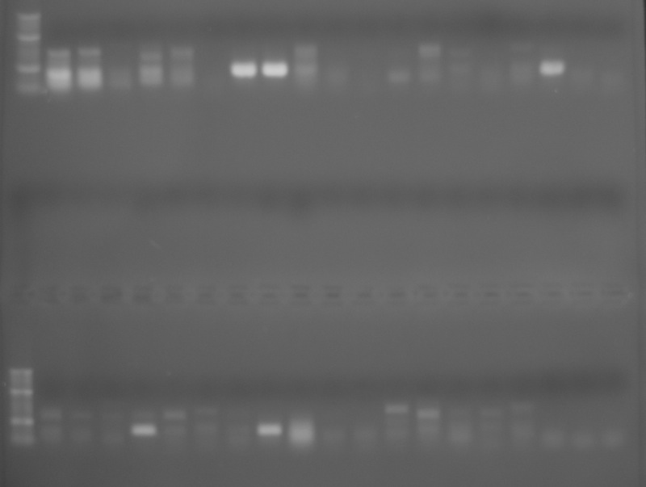  
  
**Next Step:**  
-Run Gel for ER primers

**21 February 2012**  
**Summary:**  
-Completed cDNA conversion  
-Sample CT3 & 4 and EST3 & 4  
  
**Procedure:**  
-Was completed to lab protocol  
-Stored in -20C box  
  
**Next Step:**  
-Run PCR 22 Feb

**17 February 2012**  
**Summary:**  
-Completed RNA to cDNA conversion for last 16 samples from experiment  
-Samples CT3 & 4 and EST 3 & 4  
-Already have primers necessary from July 2011, 186bps (Vitellogenin)  
  
**Procedure:**  
Table: Used 1 ug of RNA per sample  
-All procedures were done to protocol  
  
**Next Step:**  
-On 22 FEB run PCR with positive control and both vitellogenin primers  
-Run gel on new set of samples  
-Begin qPCR if samples and primers are good

**13 February 2012**  
**Summary:**  
-Wasn't able to finish RNA isolation today, will finish 14 Feb  
  
**Next Step:**  
-Finish conversion to cDNA  
-Run gel with new cDNA  
-Design Primers under 200bps

**08 February 2012**  
**Summary:**  
-Began RNA isolation  
  
**Procedure:**  
-Began isolation procedure to protocol on CT3 - CT4, EST3 - EST4  
-total is 16 samples

**07 February 2012**  
**Summary:**  
-Ran gel on 16 samples  
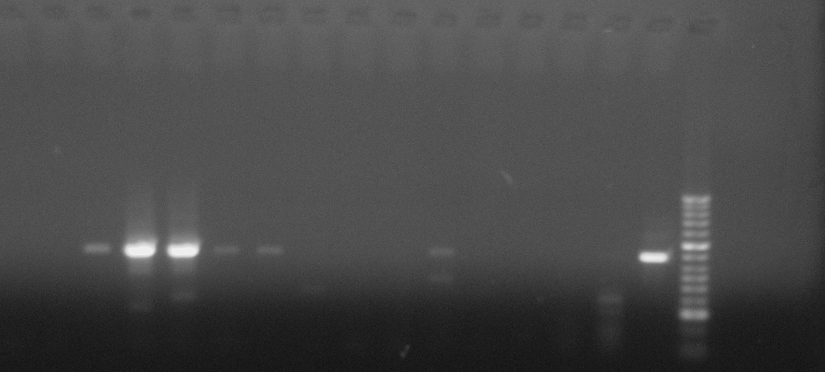  
-Read gel from right to left, right side being well #1  
-Gel turned out nicely, a red X below means a positive result for active vitellogenin gene.  
  
**Procedure:**  
GEL layout - 28 slots - .8% gel, .6g agarose

|  |  |
| --- | --- |
| WELL |  |
| 1 - HYPERLADDER | 11 - EST1 GILL X |
| 2 - POS CONTROL X | 12 - EST1 MANTLE X |
| 3 - CT1 GILL | 13 - EST 1 MUSCLE X |
| 4 - CT1 MANTLE | 14 - EST1 GONAD X |
| 5 - CT1 MUSCLE | 15 - EST2 GILL X |
| 6 - CT1 GONAD | 16 - EST2 MANTLE |
| 7 - CT2 GILL X | 17 - EST2 MUSCLE |
| 8 - CT2 MANTLE | 18 - EST2 GONAD |
| 9 - CT2 MUSCLE | 19 - NO TEMP |
| 10 - CT2 GONAD | 20 - NO TEMP |

Master Mix - same as 17 January 2012, except with 20 samples  
  
Well Plate Layout

|  |  |  |
| --- | --- | --- |
| Well 10 | Well 11 | Well 12 |
| POS CONTROL | EST1 GILL | CT1 GILL |
| NO TEMP | MANTLE | MANTLE |
| NO TEMP | MUSCLE | MUSCLE |
|  | GONAD | GONAD |
|  | EST2 GILL | CT2 GILL |
|  | MANTLE | MANTLE |
|  | MUSCLE | MUSCLE |
|  | GONAD | GONAD |

Thermocycler:  
Thermocycler parameters:  
95**°**C - 10mins  
40 cyles of:  
95**°**C - 15s  
55C - 15s  
72**°**C - 10s - 2mins  
  
**Next Step:**  
-Convert the rest of my sample to RNA this week and next week to cDNA  
-then run PCR

**06 February 2012**  
**Summary:**  
-Ran reverse transcription procedures to protocol.  
  
**Procedure:**  
Table - 1ug total RNA for each sample  
ex. 1.0ul/0.08895ug/ul = 11.30ul RNA

|  |  |  |
| --- | --- | --- |
| SAMPLE | ul RNA | ul H2O |
| CT1 GILL | 4.35 | 13.4 |
| MANTLE | 11.3 | 6.5 |
| MUSCLE | 4.68 | 13.07 |
| GONAD | 1.06 | 16.69 |
| CT2 GILL | 0.78 | 16.96 |
| MANTLE | 1.34 | 16.41 |
| MUSCLE | 1.51 | 16.23 |
| GONAD | 0.83 | 16.92 |
| EST1 GILL | 0.89 | 16.85 |
| MANTLE | 1.66 | 16.08 |
| MUSCLE | 2.28 | 15.47 |
| GONAD | 0.90 | 16.84 |
| EST2 GILL | 1.73 | 16.01 |
| MANTLE | 1.71 | 16.04 |
| MUSCLE | 5.38 | 12.37 |
| GONAD | 0.78 | 16.97 |

RNA Reverse Transcription Master Mix

|  |  |  |  |
| --- | --- | --- | --- |
| 5x Buffer | 5ul | x16 | 80ul |
| 10mM dNTPS | 1.25ul | x16 | 20ul |
| M-MLV RT | 0.5ul | x16 | 8ul |
| Total |  |  | 108ul |

**Next Step:**  
-Run PCR 7 FEB

**02 February 2012**  
**Summary:**  
-Completed RNA quantification procedures  
  
**Procedure:**  
Table - RNA quantification

|  |  |  |  |
| --- | --- | --- | --- |
| SAMPLE | ng/ul | 260/280 | 260/230 |
| CT1 GILL | 229.80 | 1.90 | 1.15 |
| CT1 MANTLE | 88.65 | 1.75 | .33 |
| CT1 MUSCLE | 213.60 | 1.85 | 1.32 |
| CT1 GONAD | 941.76 | 1.92 | 0.68 |
| CT2 GILL | 1272.62 | 1.99 | 1.67 |
| CT2 MANTLE | 744.69 | 1.92 | 1.01 |
| CT2 MUSCLE | 658.71 | 1.95 | 1.11 |
| CT2 GONAD | 1211.46 | 1.97 | 1.07 |
| EST1 GILL | 1121.69 | 1.97 | 1.89 |
| EST1 MANTLE | 601.64 | 1.97 | 1.44 |
| EST1 MUSCLE | 438.82 | 1.86 | 1.46 |
| EST1 GONAD | 1107.45 | 1.90 | 0.62 |
| EST2 GILL | 578.10 | 1.91 | 1.33 |
| EST2 MANTLE | 585.63 | 1.86 | 0.45 |
| EST2 MUSCLE | 185.91 | 1.83 | 1.61 |
| EST2 GONAD | 1290.52 | 1.98 | 1.31 |

|  |  |  |  |
| --- | --- | --- | --- |
| SAMPLE | ng/ul | 260/280 | 260/230 |
| CT3 GILL | 619.59 | 2.01 | 2.02 |
| MANTLE | 341.72 | 2.00 | 1.83 |
| MUSCLE | 111.75 | 1.81 | 1.81 |
| GONAD | 337.17 | 1.92 | 0.69 |
| CT4 GILL | 451.76 | 2.02 | 1.44 |
| MANTLE | 586.33 | 2.05 | 1.17 |
| MUSCLE | 155.96 | 1.87 | 1.54 |
| GONAD | 457.95 | 1.91 | 0.94 |
| EST3 GILL | 1100.32 | 2.08 | 1.74 |
| MANTLE | 596.05 | 2.06 | 1.01 |
| MUSCLE | 554.94 | 2.01 | 1.49 |
| GONAD | 857.73 | 2.07 | 0.77 |
| EST4 GILL | 717.12 | 2.04 | 1.05 |
| MANTLE | 256.68 | 1.94 | 0.57 |
| MUSCLE | 683.52 | 2.01 | 1.72 |
| GONAD | 567.80 | 1.93 | 0.45 |

**Next Step:**  
-Run reverse transcription procedures

**31 January 2012**  
**Summary:**  
-Completed RNA isolation procedures to protocol  
-Will begin reverse transcription 6 Feb  
  
**Next Step:**  
-Run PCR on 7 Feb with new cDNA samples

**30 January 2012**  
**Summary:**  
-Began RNA isolation procedures for 16 samples from my experiment.  
  
**Procedure:**  
-RNA isolation was done to procedure, [a copy can be found here.](http://genefish.fish.washington.edu/%7Esrlab/Derek/)  
  
**Next Step:**  
-Complete RNA and reverse transcription procedures 31 January  
-Run PCR on samples 1 FEB

**25 January 2012**  
**Summary:**  
-Ran gel with diluted samples x10, x100, x1000  
-A [photo of the finished gel can be found here](http://genefish.fish.washington.edu/%7Esrlab/Derek/01:25:2012%20derek.JPG)  
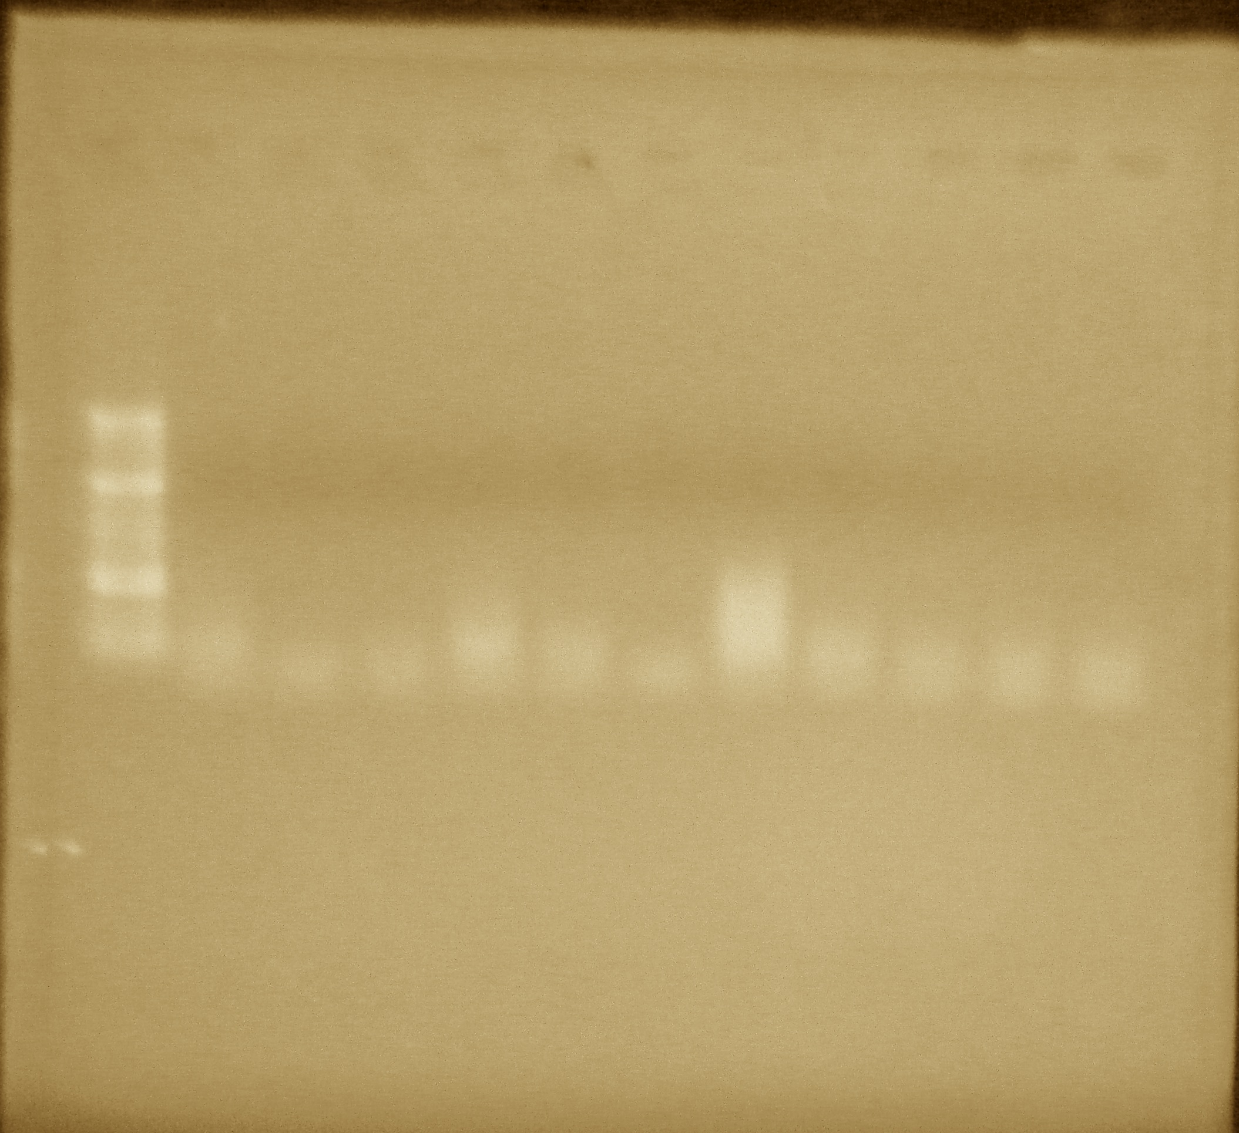  
-Smear is still present within the x10 dilution, also my no templates are contaminated. However, the same pattern is observed as with the 3 previous gels.

|  |  |  |  |  |  |  |  |  |  |  |  |
| --- | --- | --- | --- | --- | --- | --- | --- | --- | --- | --- | --- |
| Well 1 | 2 | 3 | 4 | 5 | 6 | 7 | 8 | 9 | 10 | 11 | 12 |
| Hyperladder II | CT1 Gill x10 | "" x100 | ""x1000 | EST1 Gill x10 | "" x100 | ""x1000 | EST1 Gonad x10 | ""x100 | ""x1000 | No temp. | No temp. |

**Procedure:**  
-Gel was 8% instead of 1.2% agarose  
  
**Next Step:**  
-Start from the beginning, going to create new RNA and cDNA this week.

**24 January 2012**  
**Summary:**  
-Ran gel containing experimental samples and positive control. The positive control turned out again confirming the primer, however the experimental samples came out smeared.  
-Going to run gel tomorrow with x10, x100, x1000 cDNA samples.  
-Photo of finished gel for [experimental samples can be found here.](http://genefish.fish.washington.edu/%7Esrlab/Derek/24JAN2012%20CgVg2%20with%20pos%20control.JPG)

|  |  |  |  |  |  |  |  |  |  |  |  |
| --- | --- | --- | --- | --- | --- | --- | --- | --- | --- | --- | --- |
| Well 1 | 2 | 3 | 4 | 5 | 6 | 7 | 8 | 9 | 10 | 11 | 12 |
| Hyperladder II | CT1 Gill | " " Mantle | " " Muscle | EST1 Gill | " 'Mantle | " " Muscle | " " Gonad | No temp. | No temp. |  |  |

**Procedure:**  
Diluted cDNA gel -  
-Master mix same as 23 January 2012.  
-Thermocycler temperatures and times same as 23 January 2012.  
- cDNA diluted by taking 1ul and adding 9ul H2O for x10 etc.  
  
Well Plate location:

|  |  |  |
| --- | --- | --- |
| Well | 6 | 7 |
| 1 | CT1 Gill x10 | EST1 Gonad x1000 |
| 2 | " " x100 | No template |
| 3 | " " x1000 | No template |
| 4 | EST1 Gill x10 |  |
| 5 | " " x100 |  |
| 6 | " " x1000 |  |
| 7 | EST1 Gonad x10 |  |
| 8 | " " x100 |  |

**Next Step:**  
-Run gel, if the results are no different then remake cDNA.

**23 January 2012**  
**Summary:**  
-Ran PCR testing experimental samples with positive control  
  
**Procedure:**  
-Master Mix same as 17 January 2012 expect x11 quantity.  
-Primer used was CgVg2, with a positive band at 700bp being used as the positive control for vitellogenin.

|  |  |  |
| --- | --- | --- |
| Well | 9 | 10 |
| 1 | Positive Control (Manel's) | No Template |
| 2 | CT1 Gill | No Template |
| 3 | CT1 Mantle |  |
| 4 | CT1 Muscle |  |
| 5 | EST1 Gill |  |
| 6 | EST1 Mantle |  |
| 7 | EST1 Muscle |  |
| 8 | EST1 Gonad |  |

**Next Step:**  
-Run Gel

**17 January 2012**  
**Summary:**  
-Ran gel utilizing Manel's cDNA  
-Positive control may have been found for experiment  
-For future reference CgVg2 primers came from "Molecular Characterization of a cDNA Encoding Putative Vitellogenin from the Pacific Oyster *Crassostrea gigas" by Matsumoto 2003.*  
  
**Procedure:**  
-Made identical master mix's for x2 primers.  
1. 1414/1415  
F primer: CTCAACAGCCCTGGTGGCGG SR ID: 1414  
R primer: AGCGGTTCCGACTGCTCCCT SR ID: 1415  
Product size: 723  
  
2. CgVg2  
Primer 1 (4) - 5' -GCA GAT GGA AGG ATG TCC ATC AG - 3'  
Primer 2 (5) - 5' -TTC ACA GTC ATG GAG CCC AGC AT - 3'  
Product size: 700

|  |  |  |  |
| --- | --- | --- | --- |
| Template | 1 ul | x | x |
| FWD | 0.5ul | x3.3 | 1.65ul |
| REV | 0.5ul | x3.3 | 1.65ul |
| x2 RED | 12.5ul | x3.3 | 41.25ul |
| H2O | 10.5ul | x3.3 | 34.65ul |
| Total | 25.0ul | x3.3 | x |

Thermocycler parameters:  
95**°**C - 10mins  
40 cyles of:  
95**°**C - 15s  
55C - 15s  
72**°**C - 10s - 2mins  
  
Gel - 75ml at 1.2% agarose or 0.9g agarose  
Photo [copy of the gel can be found here.](http://genefish.fish.washington.edu/%7Esrlab/Derek/20120117_01.JPG)  
Gel layout:

|  |  |  |  |  |  |  |
| --- | --- | --- | --- | --- | --- | --- |
| Well 1 | 2 | 3 | 4 | 5 | 6 | 7 |
| Hyperladder II | 1414/1415 primer | No template | No template | CgVg2 Primer | No template | No Template |

**Next Step:**  
-Run my cDNA samples with sample from today

**11 January 2012**  
**Summary:**  
-Reran gel, results suggests an abundance of double stranded DNA.  
-Correction - Going to run a separate sample of cDNA from Manel's experiment, this should eliminate whether it is my cDNA samples or my technique that is causing the problem. In addition I will run a second sample with cDNA from a CT2 and EST2 (not yet run) and compare to CT1 and EST1 (inconclusive results).  
  
**Procedure:**  
Ran gel to protocol.  
-A copy of the [gel can be found here.](http://genefish.fish.washington.edu/%7Esrlab/Derek/11%20Jan%202012%20SR%20ID%201414,%201415.JPG)  
  
**Next Step:**  
-Run Manel's cDNA sample with 1414 and 1415 primer.  
-Convert remaining samples to cDNA  
-Run CT2 and EST2 cDNA

**09 January 2012**  
**Summary:**  
-made master mix  
-ran samples through thermocycler  
**Procedure:**  
Master mix -for x7 samples and x2 no templates

|  |  |  |  |
| --- | --- | --- | --- |
| Template | 2ul | - | - |
| Forward Primer SR ID 1414 | 0.5 | x10 | 5.0 |
| reverse Primer SR ID 1415 | 0.5 | x10 | 5.0 |
| x2 Apex Red | 12.5 | x10 | 125 |
| Pure H2O | 9.5 | x10x | 95 |
| Totals | 25ul | 10 | 230ul |

Well plate Layout -

|  |  |  |
| --- | --- | --- |
| Well # | 3 | 4 |
| 1 | CT1 Gill | No template |
| 2 | CT1 Mantle | blank |
| 3 | CT1 Muscle | blank |
| 4 | EST1 Gill | blank |
| 5 | EST1 Mantle | blank |
| 6 | EST1 Muscle | blank |
| 7 | EST1 Gonad | blank |
| 8 | No template | blank |

Thermocycler times -  
Thermocycler parameters:  
95**°**C - 10mins  
40 cyles of:  
95**°**C - 15s  
55C - 15s  
72**°**C - 30 sec  
  
**Next Step:**  
-Run gel

**06 January 2012**  
**Summary:**  
-Ran gel containing 1414 and 1415 primers for vitellogenin  
**Procedure:**  
-Made a 24 well 150ml gel at .8% agarose and 15ul of EtBR  
Gel Layout:

|  |  |  |  |  |  |  |  |  |  |  |  |  |
| --- | --- | --- | --- | --- | --- | --- | --- | --- | --- | --- | --- | --- |
| Well # | 1 | 2 | 3 | 4 | 5 | 6 | 7 | 8 | 9 | 10 | 11 | 12 |
| Row 1 | ladder (5ul) | CT1 Gill | CT1 Gill - NT | CT1 Gill - NT | CT1 Mantle | CT1 Mantle - NT | CT1 Mantle -NT | CT1 Muscle | CT1 Muscle -NT | CT1 Muscle -NT | EST1 Gill | EST1 Gill - NT |
| Row 2 | ladder (5ul) | EST1 Gill - NT | EST1 Mantle | EST1 Mantle - NT | EST1 Mantle - NT | EST1 Muscle | EST 1 Muscle - NT | EST1 Muscle - NT | EST1 Gonad | EST1 Gonad - NT | EST1 Gonad - NT |  |

*NT = no template  
-A copy of the [gel can be found here](http://genefish.fish.washington.edu/%7Esrlab/Derek/06Jan2012%201414:1415%20SRID.JPG)  
**Conclusion:**  
-Gel is no good, contamination is present in every well.  
**Next Step:**  
-Rerun gel, only x2 no templates per primer.

**05 January 2012**  
**Summary:**  
-Obtained primer SRID's 1414 and 1415  
-Made master mix and began thermocycler  
**Procedure:**  
-Total 7 tissue samples with 2 non-templates each  
-Used 2ul of template  
WELL LAYOUT:

|  |  |  |  |
| --- | --- | --- | --- |
|  | Well 5 | Well 6 | Well 7 |
| 1 | CT1 GILL | CT1 MUSCLE NO TEMPLATE | EST1 MUSCLE NO TEMPLATE |
| 2 | CT1 GILL NO TEMPLATE | EST1 GILL | EST1 GONAD |
| 3 | CT1 GILL NO TEMPLATE | EST1 GILL NO TEMPLATE | EST1 GONAD NO TEMPLATE |
| 4 | CT1 MANTLE | EST1 GILL NO TEMPLATE | EST1 GONAD NO TEMPLATE |
| 5 | CT1 MANTLE NO TEMPLATE | EST1 MANTLE NO TEMPLATE |  |
| 6 | CT1 MANTLE NO TEMPLATE | EST1 MANTLE NO TEMPLATE |  |
| 7 | CT1 MUSCLE | EST1 MUSCLE |  |
| 8 | CT1 MUSCLE NO TEMPLATE | EST1 MUSCLE NO TEMPLATE |  |

Thermocycler parameters:  
95**°**C - 10mins  
40 cyles of:  
95**°**C - 15s  
55C - 15s  
72**°**C - 30 sec  
  
**Next Step:**  
-Run gel tomorrow

**03 January 2012**  
**Summary:**  
-Will run a gel using Manel's primers for Vitellogenin, which indicated a positive product of 723bps.  
**Procedure:**  
- Manel's Primer information  
F primer: CTCAACAGCCCTGGTGGCGG SR ID: 1414  
R primer: AGCGGTTCCGACTGCTCCCT SR ID: 1415  
Product size: 723  
Thermocycler parameters:  
95**°**C - 10mins  
40 cyles of:  
95**°**C - 15s  
55C - 15s  
72**°**C - 30 sec

**30 September 2011**  
**Summary:**  
-Ran gel containing CgVg2 Primers.  
**Procedure:**  
-Gel was ran to protocol.

|  |  |
| --- | --- |
| Well 1 | CT1 Gill CgVg2 |
| 2 | CT1 Gill CgVg2 - No Template |
| 3 | CT1 Gill CgVg2 - No Template |
| 4 | CT1 Mantle CgVg2 |
| 5 | CT1 Mantle CgVg2 - No Template |
| 6 | CT1 Mantle CgVg2 - No Template |
| 7 | EST1 Gill CgVg2 |
| 8 | EST1 Gill CgVg2 - No Template |
| 9 | EST1 Gill CgVg2 - No Template |
| 10 | EST1 Mantle CgVg2 |
| 11 | EST1 Mantle CgVg2 - No Template |
| 12 | EST1 Mantle CgVg2 - No Template |
| 13 | EST1 Gonad/ D.G. CgVg2 |
| 14 | EST1 Gonad/ D.G. CgVg2 - No Template |
| 15 | EST1 Gonad/ D.G. CgVg2 - No Template |
| 16 | Hyper Ladder 1 |

-Photo of finished gel can be [found here.](http://genefish.fish.washington.edu/%7Esrlab/Derek/30Sep2011CgVg2%281%29.jpg)

**16 September 2011**  
**Summary:**  
-Ran gel containing CgER2 primer.  
**Procedure:**  
-Gel was ran to protocol.

|  |  |
| --- | --- |
| Well 1 | Hyperladder 1 |
| 2 | CT1 Gill ER2 |
| 3 | CT1 Gill CgER2 - No Template |
| 4 | CT1 Gill CgER2 - No Template |
| 5 | CT1 Mantle ER2 |
| 6 | CT1 Mantle CgER2 - No Template |
| 7 | CT1 mantle CgER2 - No Template |
| 8 | EST1 Gill ER2 |
| 9 | EST1 Gill CgER2 - No Template |
| 10 | EST1 Gill CgER2 - No Template |
| 11 | EST1 Mantle ER2 |
| 12 | EST1 Mantle CgER2 - No Template |
| 13 | EST1 Mantle CgER2 - No Template |
| 14 | EST1 Gonad/ D.G. ER2 |
| 15 | EST1 Gonad/D.G. CgER2 - No Template |
| 16 | EST1 Gonad/D.G. CgER2 - No Template |

-Photo of finished gel can be [found here.](http://genefish.fish.washington.edu/%7Esrlab/Derek/16Sep2011.JPG)  
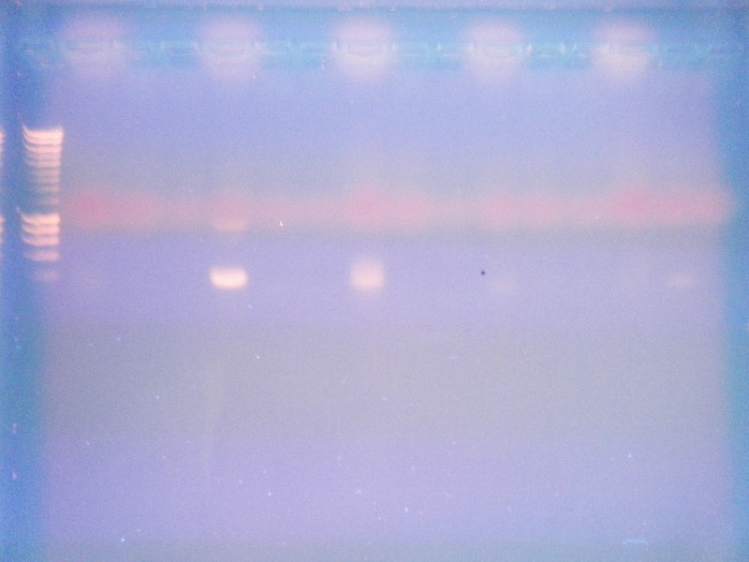  
Next Step:  
-Run CgVg2 Gel.  
-Write Proposal.

**14 September 2011**  
**Summary:**  
-Ran PCR for 13 Sep 2011 samples A1-F1.  
**Procedure:**  
Table for Sample Placement

|  |  |  |  |  |  |
| --- | --- | --- | --- | --- | --- |
| Well # | Sample | Tissue | Primer Type | Temp | Controls |
| 3 | CT1 | Gill | CgER2 | A | B & C |
| 4 | CT1 | Mantle | CgER2 | A | B & C |
| 5 | EST1 | Gill | CgER2 | A | B & C |
| 6 | EST1 | Mantle | CgER2 | A | B & C |
| 7 | EST1 | Gonad/ D.G. | CgER2 | A | B & C |
| 8 | CT1 | Gill | CgVg2 | A | B & C |
| 9 | CT1 | Mantle | CgVg2 | A | B & C |
| 10 | EST1 | Gill | CgVg2 | A | B & C |
| 11 | EST1 | Mantle | CgVg2 | A | B & C |
| 12 | EST1 | Gonad/ D.G. | CgVg2 | A | B & C |

Thermo-cycler times:

|  |  |
| --- | --- |
| 1. 95C | 10 mins |
| 2. 95C | 15 secs |
| 3. 60C | 15 secs |
| 4. 72C | 15 secs |
| 5. 72C | 10 mins |

**Next Step:**  
-Run gel

**13 September 2011**  
**Summary:**  
-Ran reverse transcription procedure on 30 August tissues.  
-Re ran CT1 Muscle; CT1 Gonda/Digestive Gland; and EST1 Muscle tissues through RNA isolation procedures.  
**Procedure:**  
-All procedures were ran to protocol.

|  |  |  |  |
| --- | --- | --- | --- |
| Location | Name | RNA (ul) | H2O (ul) |
| A1 | CT1 Gill | 2.20 | 15.60 |
| B1 | CT1 Mantle | 4.60 | 13.20 |
| D1 | EST1 Gill | 4.0 | 13.70 |
| E1 | EST 1 Mantle | 2.4 | 15.30 |
| F1 | EST 1 Gonad/D.G. | 6.0 | 11.75 |

-EST1 Gonad/D.G. was diluted with nano H2O then added to respective well.  
RT Master Mix:

|  |  |  |  |  |
| --- | --- | --- | --- | --- |
| Name | (ul) | 1. RXN | +10% | Final Total (ul) |
| x5 Buffer | 5 | 5 | .1 | 27.5 |
| dNTPs | 1.25 | 5 | .1 | 6.88 |
| RT Primer | .5 | 5 | .1 | 2.75 |

**Next Step:**  
-Run gel to determine if I am getting a response.  
-Finish proposal for senior capstone.

**12 September 2011**  
**Summary:**  
-Finished calculations for reverse transcription of first five tissues.  
-Began proposal for senior capstone.  
**Next Step:**  
-Run RT procedure.  
-Run Gel  
-Finish proposal.

**30 August 2011**  
**Summary:**  
-Completed RNA extraction for samples CT1 and EST1.  
-CT1 samples for a single specimen completed. Total 2 samples (gill, mantle)  
-EST 1 samples for a single specimen were completed. Total 3 samples (gill, mantle, gonad/digestive gland)  
-Couldn't separate supernatant from CT1 (muscle, gonad/digestive gland) and EST1 (Muscle). These three were place in the -80C box for storage.  
-It was determined after the last PCR ran that ER2 and Vg2 will be used for identification of the genes.  
**Procedure:**  
-RNA extraction was ran to protocol.  
-Added 50ul to each tube except gonad added 75ul.

|  |  |
| --- | --- |
| Tissue | ng/ul |
| CT1 Gill | 463.4 |
| CT1 Mantle | 218.0 |
| EST 1 Gill | 248.0 |
| EST 1 Mantle | 410.5 |
| EST 1Gonad/D.G. | 1685.7 |

**Next Step:**  
-Convert RNA to cDNA  
-Run PCR on all samples from specimens CT1 and EST.

**17 August 2011**  
**Summary:**  
-Completed PCR for ER1, ER2, Vg1, and Vg2 primers.  
-Copy of gel can be [found here.](http://genefish.fish.washington.edu/%7Esrlab/Derek/17aug2011allprimers.jpg)

|  |  |  |  |  |  |  |  |  |  |  |  |
| --- | --- | --- | --- | --- | --- | --- | --- | --- | --- | --- | --- |
| Well 1 | 2 | 3 | 4 | 5 | 6 | 7 | 8 | 9 | 10 | 11 | 12 |
| Ladder 1 (10k-200) | ER1 Control | ER1 Primer ~200bp | Blank | ER2 Control | ER2 Primer ~200bp | Blank | Vg1 Control | Vg1 Primer ~200bp | Blank | Vg2 Control | Vg2 Primer ~900bp |

-At 1205 began dissection of oyster tissues. Controls were dissected first.  
**Procedure:**  
-Tissue collection: Total of eight oysters at 4-5 tissues selected from each oyster.  
1. Gill 2. Mantle 3. Muscle 4. Gonad/(5.) Digestive gland  
-The gonad and digestive gland were combined.  
-All procedures were done to protocol.  
-Tubes were labeled with date/ Control (green) or Estradiol (orange)/ Oyster Number/ tissue type. Stored in -80C freezer.  
**Next Step:**  
-Verify PCR  
-Start extraction

**16 August 2011**  
**Summary:**  
-Experiment began at 1205  
**Procedure:**  
-Setup:  
x2 tanks (5L) each were filled with 2L seawater.  
Airstones and pump supply O2.  
Lids were placed over both tanks.  
Oysters were weighed dry before being placed in respective tanks x4 C.gigas.  
Total for Control Tank (384.79g) Total for Tank (E) (459.88g)  
Each tank was given ~2mL of Instant Algae  
Control tank: added 100uL Ethanol, Tank (E): Added 100ul Solution for a concentration of 50ng/L 17 Alpha-Ethinylestradiol.  
Exposure to run 24hours.  
**Next Step:**  
-Run PCR  
-Collect tissues in 24hours.

**15 August 2011**  
**Summary:**  
-Need to retest all primers again with higher annealing temperature (60C)  
-Lengths for primers cgER2 (>200bp) and cgVg2 (~900bp).  
-Designed experiment for quick trial  
Tank 1 (2L): Control, x4 C.gigas with 100ul Ethanol added.  
Tank 2 (2L): Tank (E), x4 C.gigas with 100ul solution. Total concentration is at 50ng/L of 17 Alpha-Ethinylestradiol, the estradiol was dissolved in 100% ethanol.  
-Obtained x8 oyster (C.gigas)  
**Procedure:**  
-To calculate concentration needed I referenced [Andrew, 2008](http://www.sciencedirect.com/science/article/pii/S0166445X08000842) (50ng/L)  
-100mg of 17 Alpha-Ethinylestradiol added to 10mL Ethanol. Equation (100mg/.01L) (V1) = (5e^-5) (2L), V1 = 100uL solution.  
-Planned exposure is 24hours.  
**Next Step:**  
-Set up Experiment  
-Need to retest all primers again with higher annealing temperature (60C)

**10 August 2011**  
**Summary:**  
-made master mixes for new primers cgER2 and cgVg2.  
-Ran PCR.  
-Ran gel a finished photo [can be found here](http://genefish.fish.washington.edu/%7Esrlab/Derek/ERVg22011aug10.jpg). [Close up](http://genefish.fish.washington.edu/%7Esrlab/Derek/ERVg22011Aug10-2.jpg).

|  |  |  |  |  |
| --- | --- | --- | --- | --- |
| Hyper ladder 1 | ER Control | cgER2 | Vg Control | cgVg2 |
| >200 |  |  |  |  |

**Procedure:**  
-Master Mix for cgER2

|  |  |  |  |
| --- | --- | --- | --- |
| Template | 2ul | n/a | n/a |
| Primer FWD SRI key: | 0.5ul | x2.2 | 1.1ul |
| Primer REV SRI key: | 0.5ul | x2.2 | 1.1ul |
| x2 Apex Red | 12.5ul | x2.2 | 27.5ul |
| Nano H2O | 9.5ul | x2.2 | 20.9ul |
| Totals | 25ul | n/a | 50.6ul |

-Master Mix for cgVg2

|  |  |  |  |
| --- | --- | --- | --- |
| Template | 5ul | n/a | n/a |
| Primer FWD SRI key: | 0.5ul | x2.2 | 1.1ul |
| Primer REV SRI key: | 0.5ul | x2.2 | 1.1ul |
| x2 Apex Red | 12.5ul | x2.2 | 27.5ul |
| Nano H2O | 6.5ul | x2.2 | 14.3ul |
| Totals | 25ul | n/a | 44.0ul |

-PCR times: 1 cycle 95C 10mins, 39 Cycles 95C 15s, 55C 15s, 72C 30s, 1 cycle 72C 10mins  
-Gel was made of 1.2% agarose. 75ml gel with .9g agarose.  
**Next Step:**  
-Design experimental setup

9 August 2011  
**Summary:**  
-Ordered new primers for ER and Vg as outlined in Matsumoto. T et al, 2003/2007.  
-CgER2 - FWD 5'-CCT ACT CGA CCC CTC CCT ATC - 3' 21bp  
-CgER2 - REV 5'-CAC CCC TCA CAT GAC CAC AC - 3' 20bp  
-CgVg2 - FWD 5'-TTC ACA GTC ATG GAG CCC AGC AT -3' 23bp  
-CgVg2- REV 5'-GCA GAT GGA AGG ATG TCC ATC AG -3' 23bp  
-Ordered 17 Alpha-Ethinylestradiol 100mg.  
**Next Step:**  
-Run new primers  
-Design experimental setup

2 August 2011  
**Summary:**  
-Vitellogenin is produced within the ovary's of female C. gigas (Matsumoto T., 2003) Also from this paper 2 primers were identified and will be ordered.  
Primer 1 (4) - 5' -GCA GAT GGA AGG ATG TCC ATC AG - 3'  
Primer 2 (5) - 5' -TTC ACA GTC ATG GAG CCC AGC AT - 3'  
-The thermocycler times used were also different within the Matsumoto, 2003 journal and consisted of 1 cycle 92C 1min, 40 cycles 92C 1min, 55C 1min, 72C 1min, and 1 cycle 72C 5min. These temperatures may be used for next PCR.  
-Circulation of estrodial-17B flows significantly toward the digestive glands of C. gigas where a large percent is converted to estrone by 17B-HSD. (Le-Curiurx Belfond O., 2005).  
-Ran Gel with various tissues from C. gigas ( mantle, gill, muscle, gonads, digestive gland (none sex specific). Photo of Gel can be [found here](http://genefish.fish.washington.edu/%7Esrlab/Derek/2011aug02-03.jpg).  
-Results varied from test with only mantle tissue, the ER primer presented a band <200bp and another around 700bp. The ER control was negative for product. The VTG primer shows many bands ranging from 700bp to < 200bp and the control also shows contamination.  
**Procedure:**  
-Ran gel to protocol.  
**Next Step:**  
-Order primers for VTG (Vg)  
-Run primers with 5ul of template  
-Research work done on VTG expression.  
-Design Experiment  
-Collect oysters

1 August 2011  
**Summary:**  
-Made Separate master mixes for ER and VTG primers.  
-made gel with 0.9g agarose  
**Procedure:**  
-Same master mix procedure used as 13 July 2011, only change was template used.  
-Samples ran at 95C-15s, 55C-15s, 72C-30s.  
**Next Step:**  
-Run electrophoresis

22 July 2011  
**Summary:**  
-ER and VTG controls were both negative. Photo found on 13 July 2011 link.  
-The ER primer gave a positive product band below 200bp.  
-The VTG primer, a slight band occurred, small product most likely due to the tissue used. The mantle tissue used originally would not likely have high expression since VTG is an egg-yolk precursor.  
**Next Step:**  
-Run VTG primers with multiple tissues.

13 July 2011  
**Summary:**  
-Made separate master mixes for ER and VTG primers.  
-Ran Electrophoresis on samples.  
-Copy of completed gel can be [found here](http://genefish.fish.washington.edu/%7Esrlab/Derek/20110713%20Gel.JPG).  
**Procedure:**  
-Master mixes x2 were made as follows.

|  |  |  |  |
| --- | --- | --- | --- |
| Template | 2ul | n/a | n/a |
| x2 Apex Red | 12.5ul | x2.2 | 27.5ul |
| Primer FWD ER SRI Key -1343 VTG SRI Key - 1345 | 0.5ul | x2.2 | 1.1ul |
| Primer REV ER SRI Key -1344 VTG SRI Key - 1346 | 0.5ul | x2.2 | 1.1ul |
| Nano H2O | 9.5ul | x2.2 | 20.9ul |
| Total | 25ul | n/a | 50.6ul each MM |

-Well Plate Configuration.  
-Added 23ul of appropriate master mix to each well.  
-Then added template (2ul) (cDNA from C1 Crassostrea gigas) and control H2O (2ul).

|  |  |
| --- | --- |
| Well Number | 10 |
| Neg ER Control | added 2ul nano H2O |
| ER Sample | added 2ul of C1 |
| Neg VTG Control | added 2ul nano H2O |
| VTG Sample | added 2ul of C1 |

-Thermal Cycle was done to protocol except 72C was extended to 30secs per cycle.  
**Next Step:**

12 July 2011  
**Summary:**  
-Researched past studies involving contraceptive chemicals and aquatic species.  
-Researched active ingredient of birth control, there are many variations of the active ingredient between BC's.  
-A common synthetic estrogen used in studies is EE2 (17a-Ethinylestradiol), Kidd et al, 2010., Wessel et al, 2007.  
**Next Step:**  
-Run ER & VTG primers

11 July 2011  
**Summary:**  
-Researched mammalian estrogen pathways  
-Ran BLAST for Crassostrea gigas Estrogen Receptor cds, Accession # HS180695.1  
-Ran BLAST for C. gigas Vitellogenin cds, Accession # AB084783  
-Designed Primers for ER (SRI Keys 1343 & 1344) and Vitellogenin (SRI Keys 1345 & 1346)  
**Procedure:**  
-Coding sequences taken from NCBI/Genbank  
-Primers designed with Geneious  
**Next Step:**  
-Run primers to test for product  
-Research main compounds of synthetic birth control

01 July 2011  
**Summary:**  
-Ran electrophoresis gel  
**Procedure:**  
-Photo of [finished gel](http://genefish.fish.washington.edu/%7Esrlab/Derek/20110701.JPG)  
**Next Step:**  
-Research experimental design

24 June 2011  
**Summary:**  
-Made agarose gel  
**Procedure:**  
1. Used 75ml of TAE  
2. At .8% agarose, .6g agarose for 75ml solution  
3. Weighed (278g) then heated for 2 min till all particulate disappeared  
4. Removed swirled and added nano water to replace evaporated solution  
5. Added 7.5uL Ethidum Bromide to solution  
6. Waited to room temperature, poured gel  
7. Wait 20min till hardened  
**Next Step:**  
-Run gel

20 June 2011  
0900-1500  
**Summary:**  
-Began PCR procedure to protocol.  
-Researched estrogenic effects on C. gigas for proposal  
-Reviewed transcription processes  
**Procedure:**  
-Made master mix as following

|  |  |  |  |
| --- | --- | --- | --- |
| Template | 2ul | n/a | n/a |
| 2x APEX | 12.5ul | x6 | 75ul |
| Defensin Primer SRI-KEY 1070 & 1109 | 0.5ul | x6 | 3ul |
| Nano H2O | 10ul | x6 | 60ul |
| Totals for Master Mix | 25ul |  | 138ul |

-Placed into well plate with 23ul each of master mix, as following

|  |  |
| --- | --- |
| Row | Column 3 |
| 1 | Sample C1 |
| 2 | Sample C2 |
| 3 | RT Control |
| 4 | PCR Control |
| 5 | PCR Control |

-Cycling parameters used:

|  |  |
| --- | --- |
| 95C | 10min |
| 40 cycles of |  |
| 95C | 30sec |
| 50C | 30sec |
| 72C | 2min 30sec |

-Placed container into -20C box.  
**Next Step:**  
-Create and run electrophoresis

27 May 2011  
**Summary:**  
-Ran reverse transcription procedures to protocol for samples C1, C2, and control.  
-Placed samples in -20C freezer.  
  
**Next Step:**  
-Perform PCR procedures

**24 May 2011**  
**Summary:**  
-Finished mrna isolation procedure to protocol.  
-ran spec on samples.  
-Made -80C box and placed samples on top shelf.  
**Procedure:**  
-spec was run using Nanodrop

|  |  |  |  |  |  |  |  |  |  |
| --- | --- | --- | --- | --- | --- | --- | --- | --- | --- |
| Sample | ng/ul | A260 | A280 | 260/280 | 260/230 | Constant | Cursor Pos. | Cursor Abs. | 340 raw |
| C1 | 374.10 | 9.352 | 4.852 | 1.93 | 1.60 | 40.00 | 230 | 5.828 | 0.379 |
| C2 | 956.07 | 23.902 | 12.254 | 1.95 | 1.16 | 40.00 | 230 | 20.595 | 1.766 |

**Next Step:**  
-Start cdna procedures

**23 May 2011**  
**Summary:**  
-Began mrna isolation procedures using *Crassostrea gigas* tissue.  
**Procedure:**  
-mrna isolation was done to protocol.  
**Next Step:**  
-Next step would be to treat with DNAase.  
-make cdna from rna and then perform pcr on samples.

**12 May 2011**  
**Summary:**  
-Ran samples from 04 May 2011  
**Procedure:**  
-Loaded gel with marker of known size close to that of defensin gene.  
-Loaded gel with control, DH, and BB samples.  
-Ran electrophoresis for 25min.  
-Examined under UV light  
-Here is a foto of the [finished gel](http://genefish.fish.washington.edu/%7Esrlab/Derek/12may2011.jpg)  
**Next Step:**  
-Repeat procdure for practice.  
-Move onto rna isolation procedures.

**09 May 2011**  
**Summary:**  
-Poured electrophoresis gels  
**Procedure:**  
-Decide volume of gel needed, add to flask.  
-Add 0.08% agarose, weigh flask, heat sample to boiling, remove and swirl to remove any particulates, reheat if necessary.  
-Place on scale replace evaporated mix with nano water, add about 1 gram more then previous weight to account for evaporation.  
-Place solution into gel mold, wait 30min.  
**Next Step:**  
-Ran out of time, placed completed gel into the fridge. Tomorrow finish electrophoresis.

**04 May 2011**  
**Summary:**  
-Copy of master mix can be found [here.](http://genefish.fish.washington.edu/%7Esrlab/Derek/2011may04-01.jpg)  
-Started PCR working with gigas cDNA.  
**Procedure:**  
-Defensin primers SRI-Key (1070 and 1109)  
-Started by producing a master mix to fill a total of 3 wells (2 cDNA, 1 control) with 23uL each, I added 10% to the mix to account for errors, see link above for exact concentrations.  
-Well A- control and was filled with 2uL of PCR water, Well B- Dreyton Harbor sample added 2uL, Well C- Big Beef Creek sample added 2uL.  
-Placed well plate into thermal cycler.  
**Next Step:**  
-Learn to pour agar gel plates and perform electrophoresis on samples.

**27 April 2011**  
**Summary:**  
-Reviewed Rna isolation procedures.  
-Completed BioSafety Training and emailed copy of cert to Sam.  
  
**Next step:**  
- Next week work on rna isolation.